**MIDDLE EAST TECHNICAL UNIVERSITY**

**DEPARTMENT OF ELECTRICAL & ELECTRONICS ENGINEERING**



**TROY TECH**

**WEEKLY REPORT #9**

**08.11.2018-11.12.2018**

**Section :** 7

**Studio Coordinator:** Mustafa Mert ANKARALI

**Partners :**

Hasan ÖZKARA - 2031888

Kağan ÖZASLAN - 2031854

Caner POTUR - 2031250

Mustafa Ercan OKATAN - 2031193

Mert KAYIŞ – 2030997

**Progresses for Previous Week:**

* We searched about increasing the range of wireless command transfer and found different options:

1. Using 433MHz 500mw Data radio modem DRF7020D27

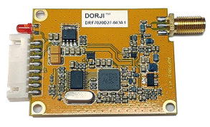

Advantages:

-Long range with default antennas (>5000m)

Disadvantages:

-Expensive (25$ each)

-Consumes lots of power

1. Using Yagi 2.4GHz 25dbi WiFi RP-SMA Antenna with NRF24L01 module

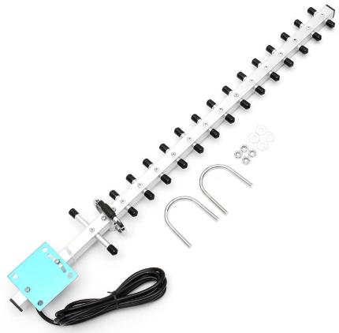

Advantages:

-Very long range with NRF24L01 wireless module (30-50km)

Disadvantages:

- Dimensions are big (44.4cm*6.8cm*1.6cm)

-Weight 230g

-Expensive (12$ each)

nRF24L01 with Yagi 14km challenge: <https://www.youtube.com/watch?v=TGnOn5YThg8>

nRF24L01 with Yagi 30km challenge: <https://www.youtube.com/watch?v=4XRp7pkZgPM>

c)Using Dark 2.4Ghz 15dBi

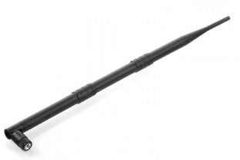

Advantages:

- Cheap (4.23$ each)

- Dimensions are more suitable than Yagi antenna

Disadvantages:

-Not found a test result

* We searched about increasing the range of video transfer. We will connect following two different antennas to our FPV Receiver module (ROTG02) to increase maximum range:

|  |  |
| --- | --- |
| DYS FPV Mushroom Antenna ( 5.8GHz 4dBi) | Realacc Triple Feed Fetch Antenna (5.8GHz 9.4dBi) |
|  |  |
| Price: $4.75 | Price: $9.99 |

**Plans for the Next Week:**

* Testing the range of wireless command transfer using Dark 2.4Ghz 15dBi Antenna with NRF24L01
* Driving the motor using PI/PID controller.
* Uniting PS1 joystick and command transfer modules.
* Discussing about test results.